Integrating CET's PMC Meters into ION Enterprise

PMC meters are compatible with Modbus networks as slaves, and can communicate easily with ION Enterprise software.

This technical note describes how to integrate PMC meters into ION Enterprise with Modbus protocol.

It assumes that the users are familiar with Modbus protocol and Modbus register maps of PMC meters which are listed in the user manual.

ION Enterprise supports the PMC meters listed below:

* PMC-43 V2.0
* PMC-53 V5.0
* PMC-51 V2.3
* PMC-530C V3.2

**Reference documentation:**

* PMC-43 Series User Manual V2.0A (20100623 - Final).pdf
* PMC-51 Series User Manual V1.5A (20100623 - Final).pdf
* PMC-53 Series User Manual V4.0A (20100623 - Final).pdf
* PMC-530 Series User Manual V3.3A (20100623 - Final).pdf
* Modbus_Device_Importer.pdf
* Modbus_and_ION_Technology.pdf
* ION_Enterprise_6.0_User_Guide.pdf

The PMC meter’s serial port has been configured with the following parameters:

* Type = RS485
* Baud rate = 9600
* Data Bits = 8
* Parity = None
* Stop Bits = 1

**Adding a Device Type to the Network Configure Database in ION Enterprise**

The Modbus Device Importer utility enables ION Enterprise software to recognize and easily integrate third-party Modbus devices into the ION Enterprise network. Use the ION Enterprise Modbus Device Importer utility to configure the Modbus device (mapping information) and add it as a Device Type to the Network Configuration database (NOM).

Once the device type is added, the Modbus device can be seen in a drop-down menu in the Management Console.

1. Launch **Management Console**, enter the right user name and password to login.
2. Navigate to **Tools**🡪**System**🡪**Modbus Device Importer…** from the Management Console user interface.

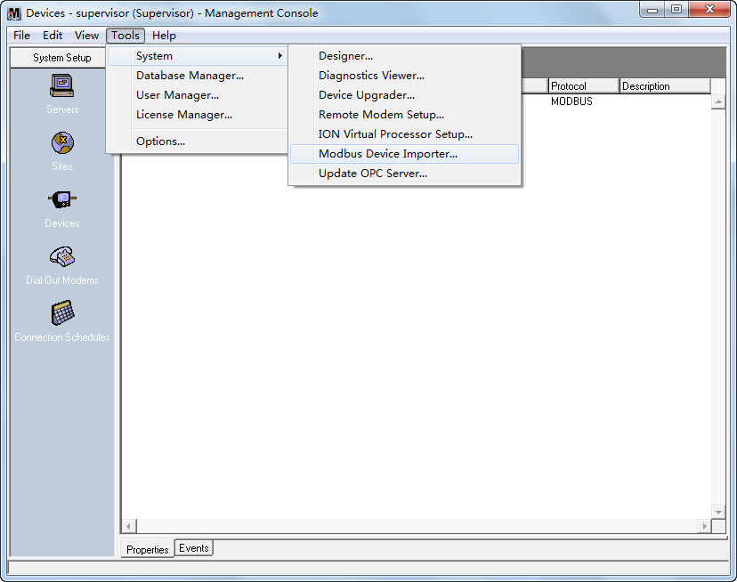

And the main console appears as follows (modbus_default.ion) :

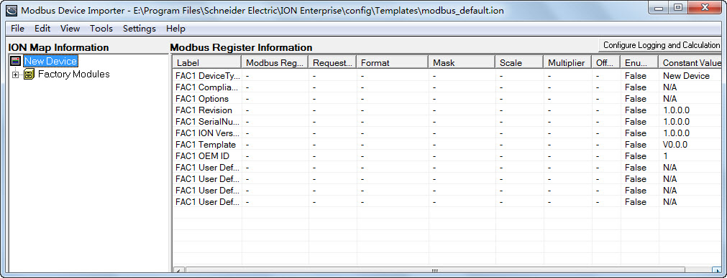

1. Right-click the **New Device** icon from the left pane in the **ION Map Information** region. Select **Advanced Properties** from the pop-up dialog box.

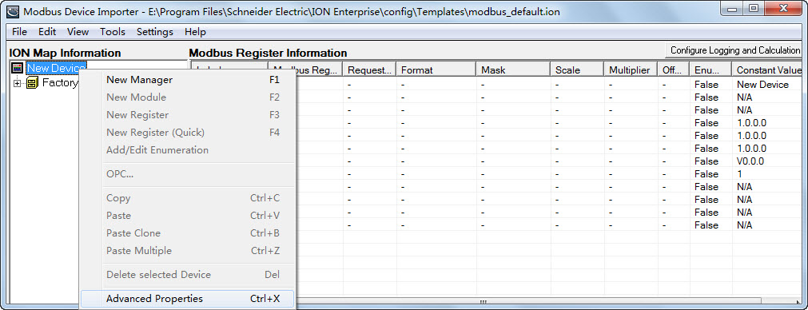

The **Device Properties** dialog box is shown as follows:

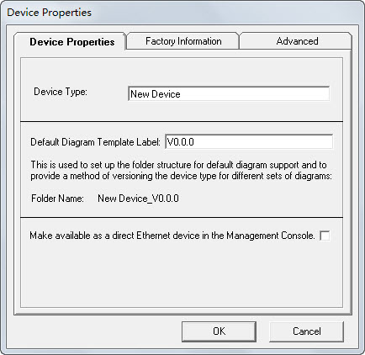

Configure the **Device Properties** according to your application.

**Device Properties Tab**

* **Device Type:** Type the name of the Device Type. For example, name the device as PMC53M if the device model is PMC-53M meter.
* **Default Diagram Template Label:** The string entered in this field is an internal identifier for the device.

1. Right-click the **New Device** icon from the left pane in the **ION Map Information** region. Select **New Manager** from the pop-up dialog box.

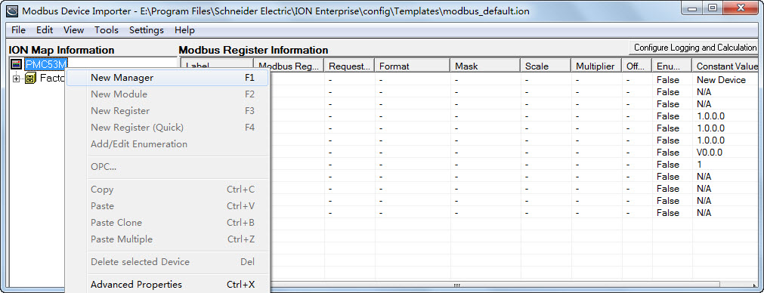

The **Add New Manager** dialog box is shown as follows:

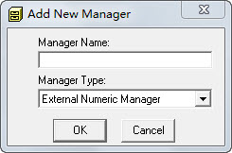

Enter the new manager name into the **Manager Name** box and select the proper manager type from the drop-down button1, then click **OK**. For example, name the manager as Power Meter Modules to identify the basic measurement parameters.

1. Right-click the **Manager** icon from the left pane in the **ION Map Information** region. Select **New Module** from the pop-up dialog box.

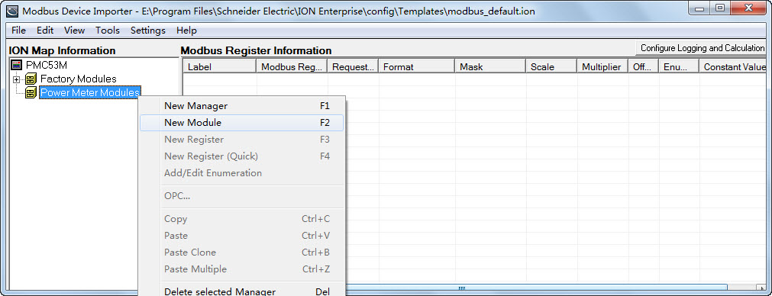

The **Add New Module** dialog box is shown as follows:

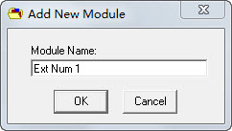

Enter the new module name into the **Module Name** box and then click **OK**. For example, name the module as Power Meter to identify the power parameters.

1. Right-click the **Module** icon from the left pane in the **ION Map Information** region. Select **New Register (Quick)** from the pop-up dialog box.

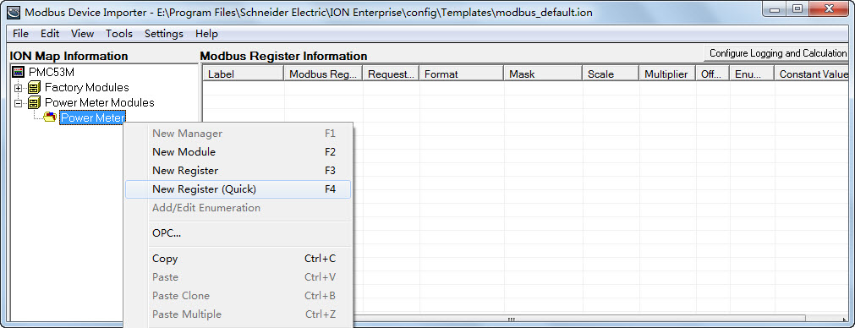

Thefollowing dialog box displays the register information. Depending on the type of register being edited, different data fields may appear.

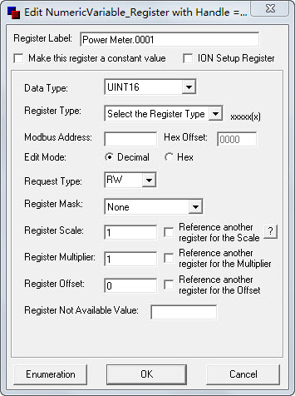

**Register Properties**

* **Register Label:** The label is an identifier for the register. For example, name the register as Vln a to identify the phase A voltage.
* **Data Type:** The data type is used for decoding the values returned from the meter. The selected data type format must match the format delivered by the device. Refer to the Modbus register map for the specific device.
* **Register Type:** It changes the most significant number in the Modbus address to correspond to the specified register type. The register type must match the register type specified by the device documentation.
* **Modbus Address:** This is the physical address of the specified register. It must match the register type specified by the device documentation.
* **Request Type:** This tells the system whether or not it can read, write or do both actions to the specified register. It must match the register type specified by the device documentation.
* **Register Scale:** This specifies what the scale factor of the data being requested should be. It must match the register type specified by the device documentation.

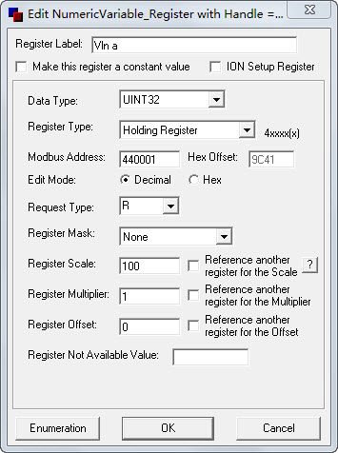

If all necessary parameters are configured, click **OK** and return to the main console. The new register Vln a appears under the tree in the left pane and detailed information of the register is shown in the right pane.

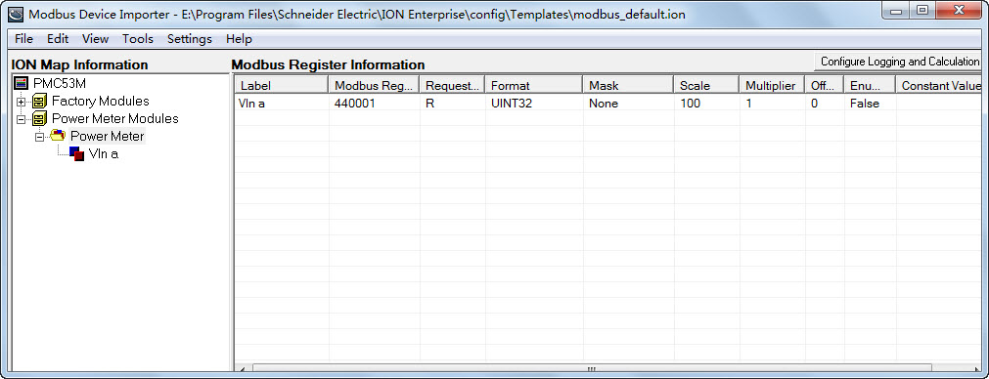

1. Right-click the **register** icon from the left pane in the **ION Map Information** region. Select **New Register (Quick)** from the pop-up dialog box to add more register.

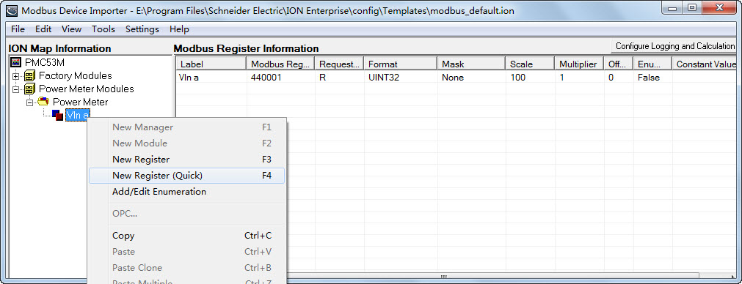

**New Register (Quick)** command adds a new register using all default settings. No dialog box is associated with this command. The label and Modbus register for the new register are sequentially numbered.

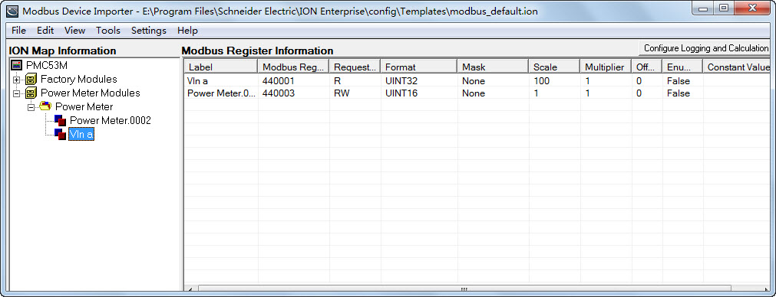

Right-click on the line of the new register in the right pane and select the **Advanced Properties** to modify the register parameters according to the device’s Modbus register map.

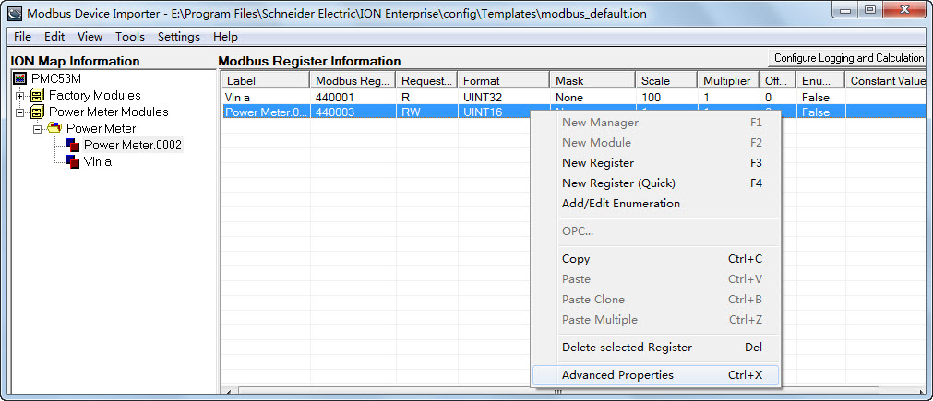

The following shows some registers that have been configured according to the PMC-53M’s Modbus register map.

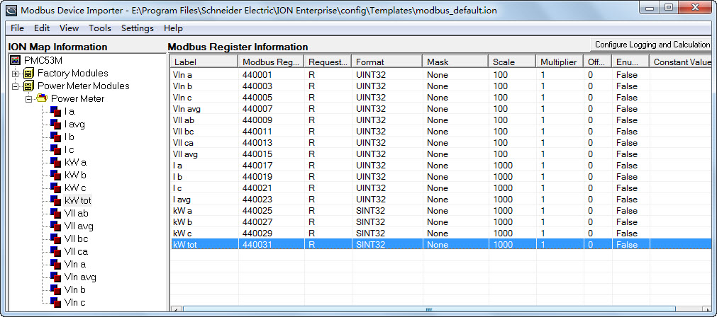

1. After editing the values, navigate to **File**🡪**Save As…** to save the current map file template and the corresponding ION tree file template (with .ion extension) to a different location.

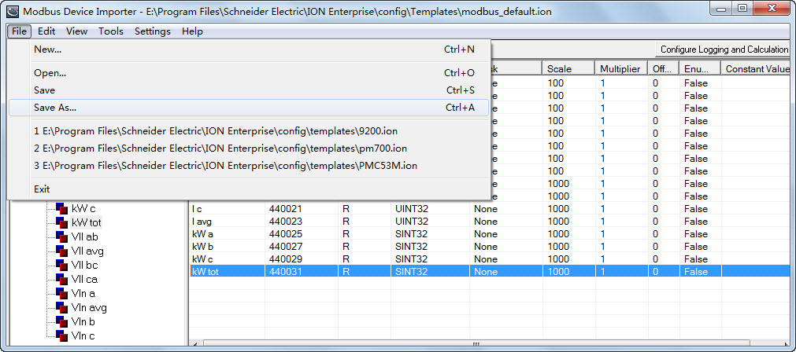

1. After you correctly configure a device and save the file template, select **Tools**🡪**Add Device Type** to add it to the ION Enterprise device type database (NOM).

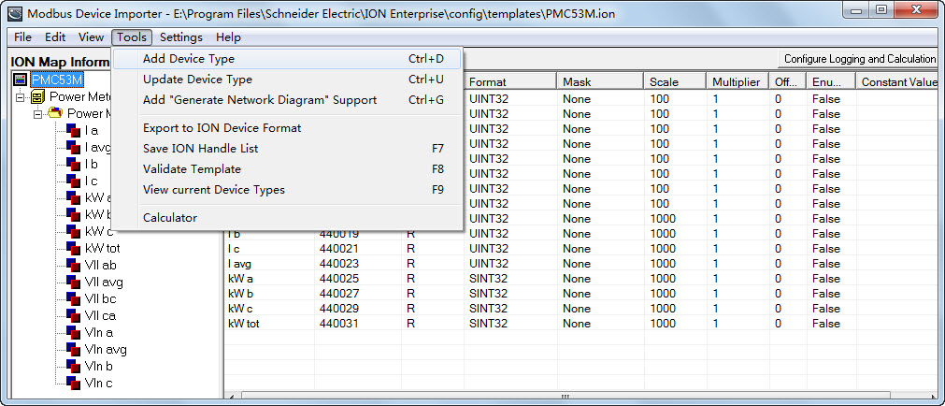

When the hint “Device Type added successfully” appears, it indicates that the new device type has been added to the ION Enterprise device type database (NOM) successfully.

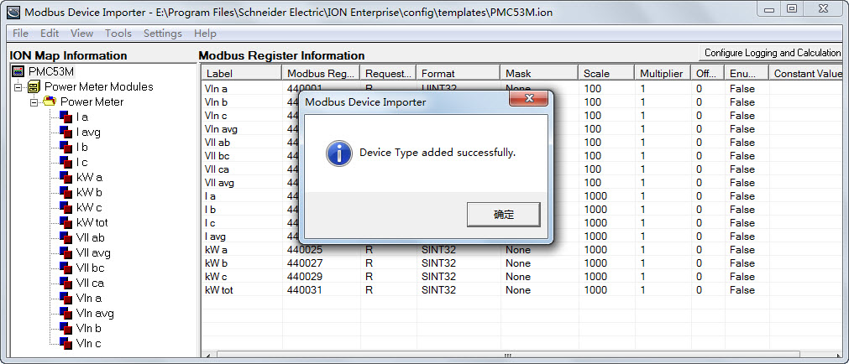

The **Current Device Types in the ION Enterprise Network** dialog box is pop-up automatically. You can find the new device type at the bottom line of the device lists.

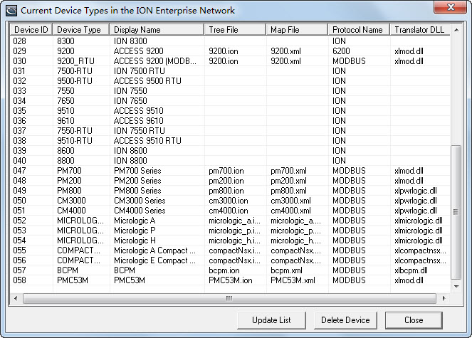

1. If you add a device type to the NOM but changes were made to the template, then you must first navigate to **File**🡪**Save** to save the template, and select **Tools**🡪**Update Device Type** to update the NOM to reflect these changes.

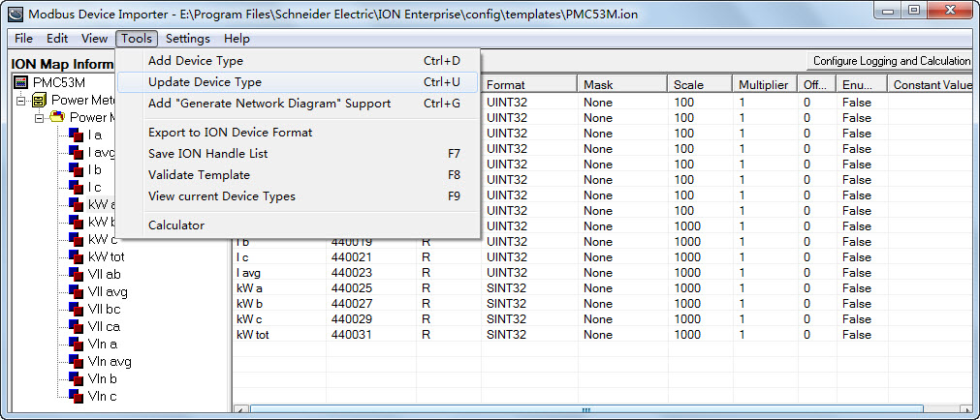

When the hint “Device updated successfully” appears, it indicates that the changes have been updated to the NOM successfully.

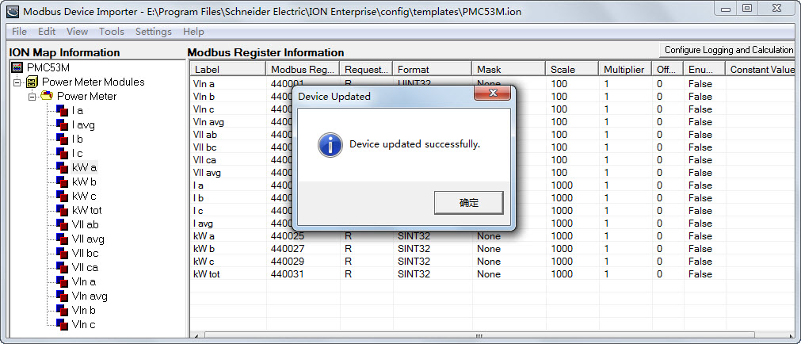

**Setting Up Your Network in Management Console**

1. Launch **Management Console**. Enter the right user name and password to login. Two default user names (“guest” and “supervisor”) are both with a default password of “0” (zero).

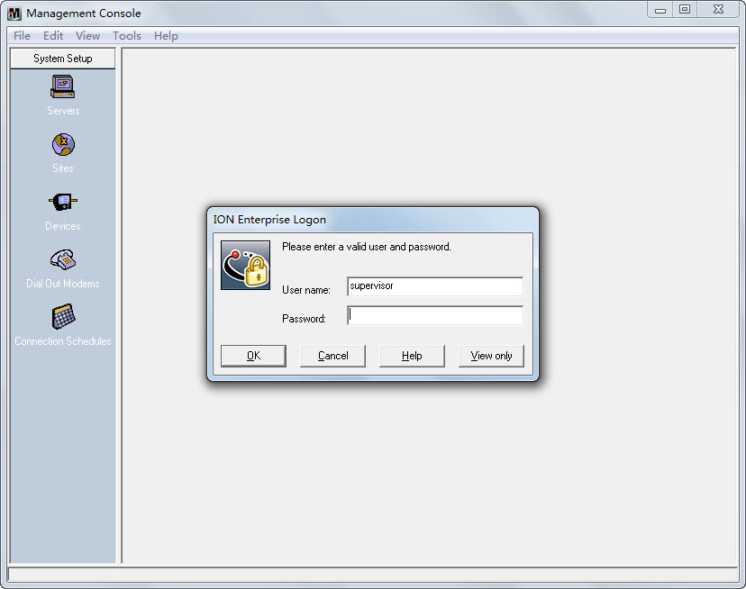

The program interface appears as follows with the default local server:

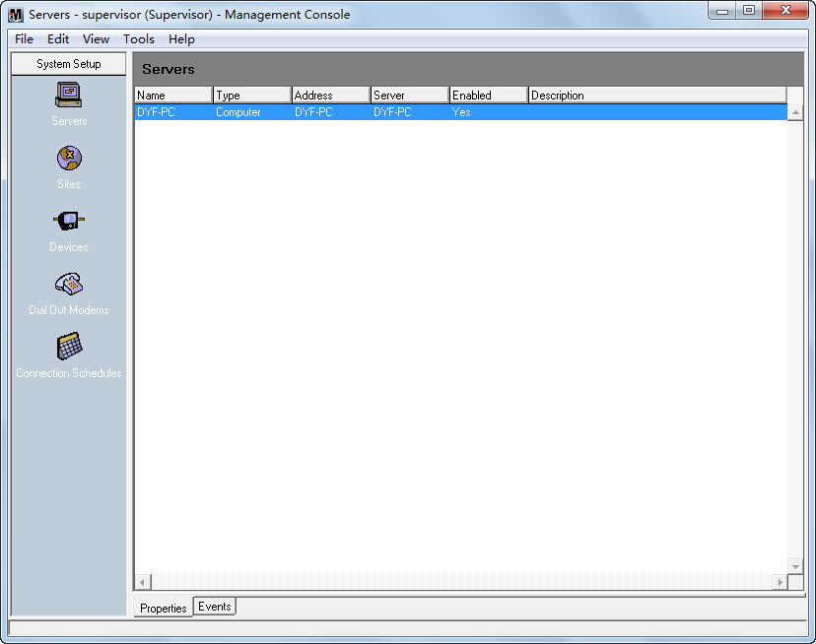

1. Click the **Sites** icon. Right-click in the display window and select **New**🡪**Direct Site…**.

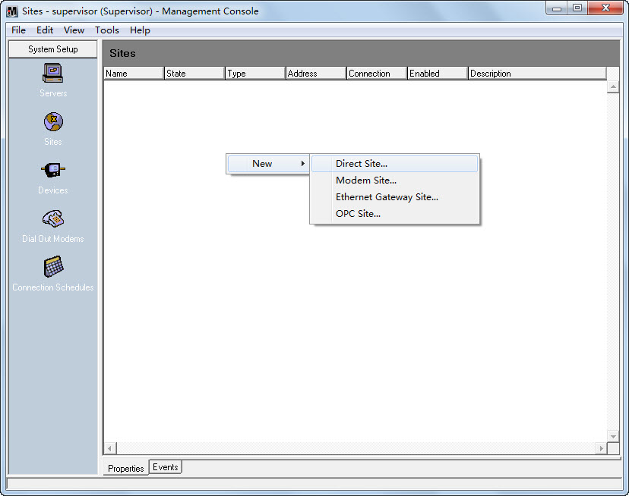

1. The **Direct Site Options** dialog box appears as follows:

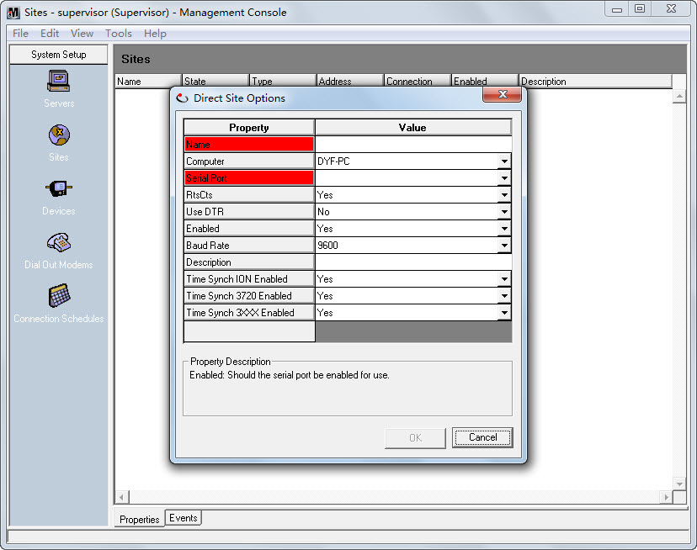

Right-click within the dialog box and select **Advanced Properties**.

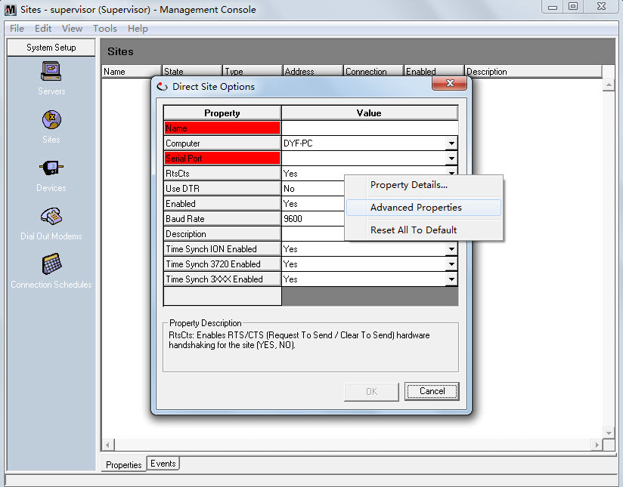

Fill in the **Name** and **Serial Port** fields. Configure the **Baud Rate**, **Transmit Delay**, **Data Bits**, **Stop Bits**, and **Parity** fields to match the communication settings in the device. Change other fields if required.

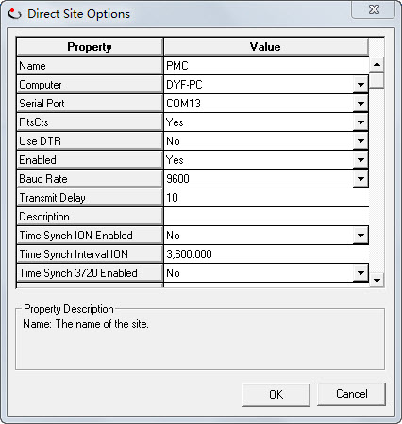

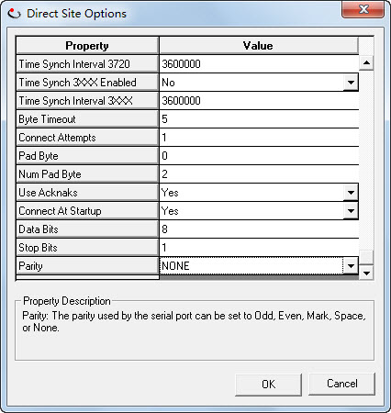

Right-click on the line of the new site and select **Connect** to connect the serial site.

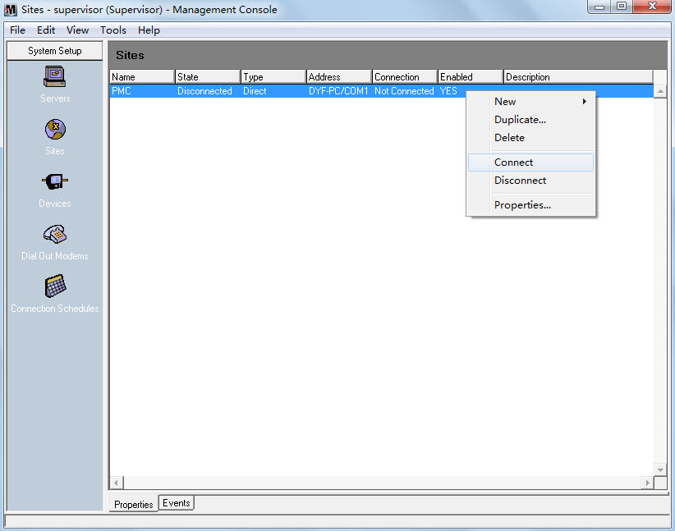

Select the connection duration type to confirm connect.

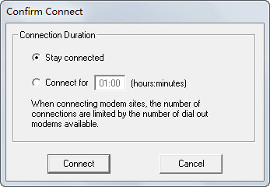

If the communicate link is OK, it shows Connected in the **State** column.

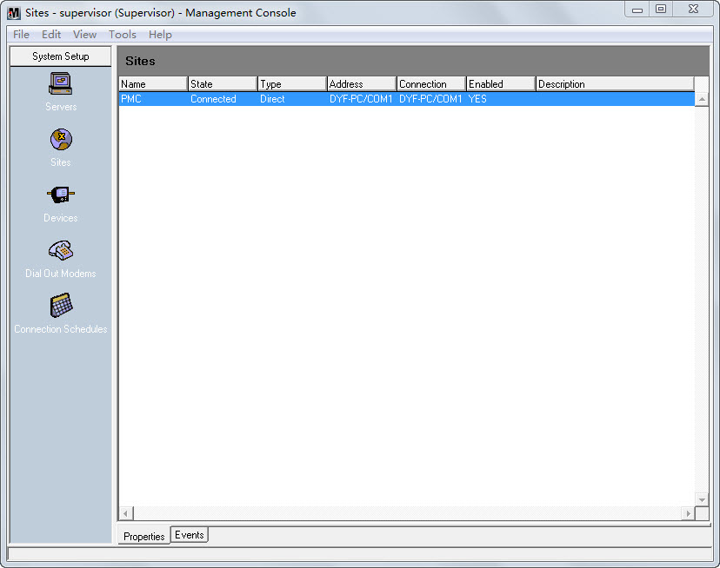

1. Click the **Devices** icon, Right-click in the display window and select **New**🡪**Serial Device on Direct Site…**.

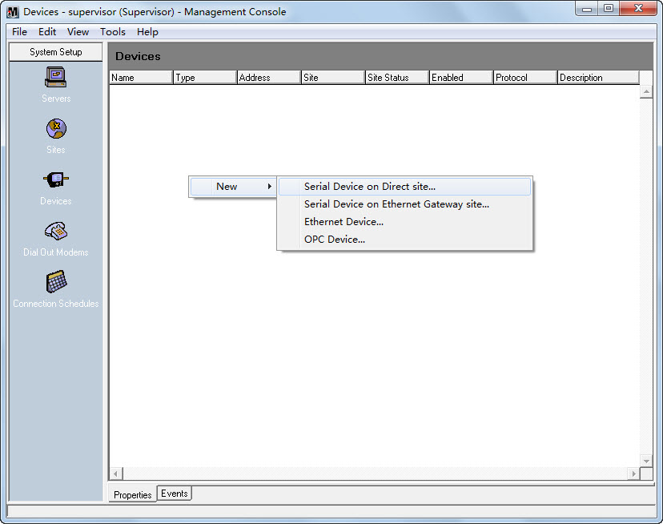

The **Serial Device Options** dialog box appears as follows:

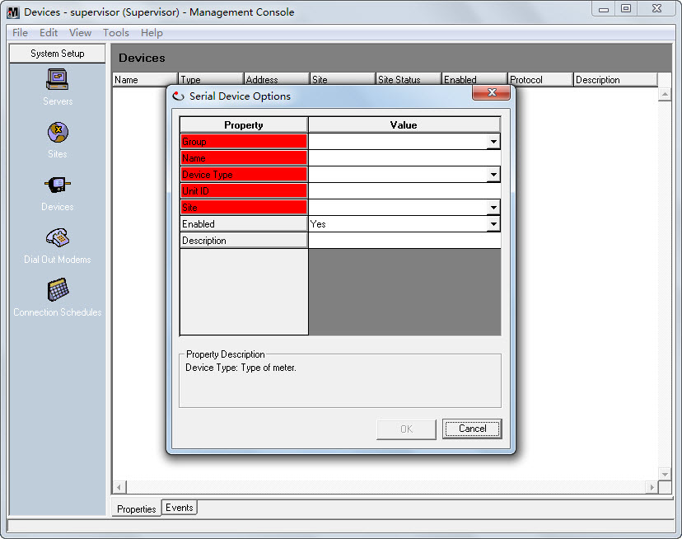

Right-click within the dialog box and select **Advanced Properties**.

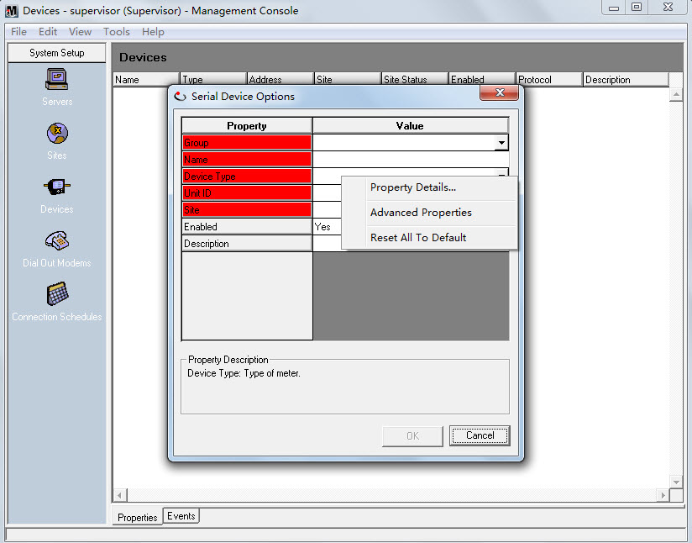

Fill in the **Group**, **Name**, **Device Type**, **Unit ID** and **Site** fields.

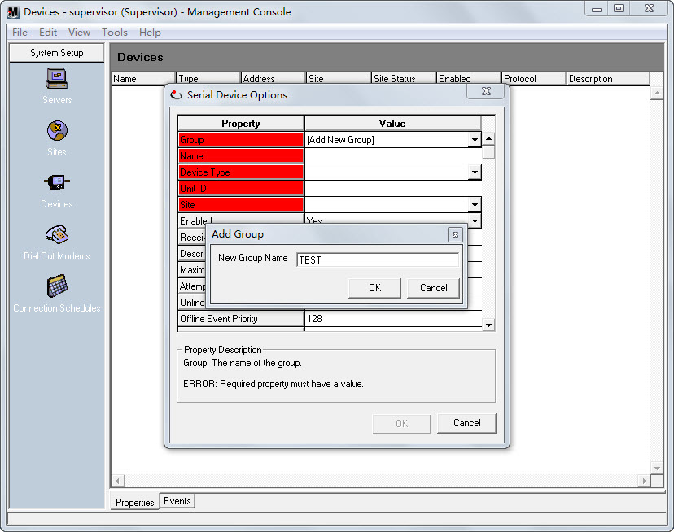

In the **Device Type** field, click the drop-down button1, you can find the PMC53M device type in the list.

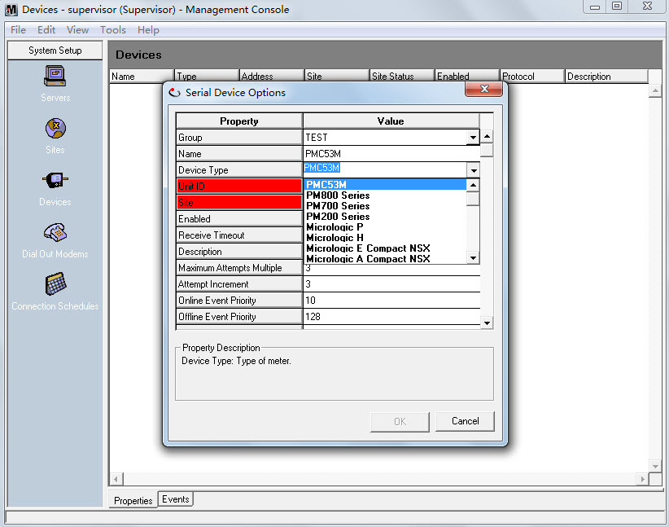

Configure the **Receive Timeout** and other fields if required.

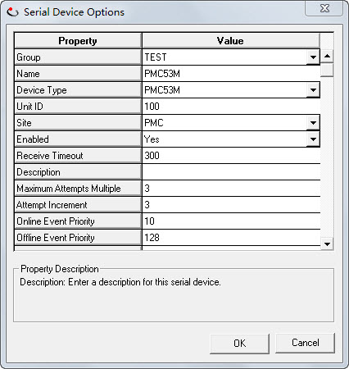

The PMC53M direct device is shown in the right pane.

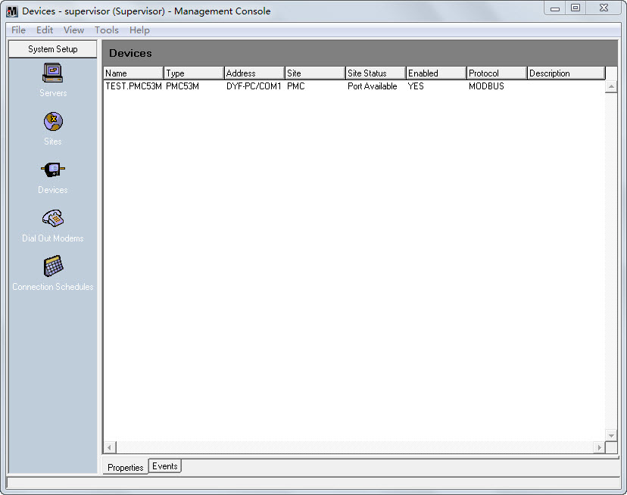

**Reading Data from Modbus Devices Using Vista**

In Vista, create and link the objects to view the register value.

1. Launch **Vista**. Enter the right user name and password to login.

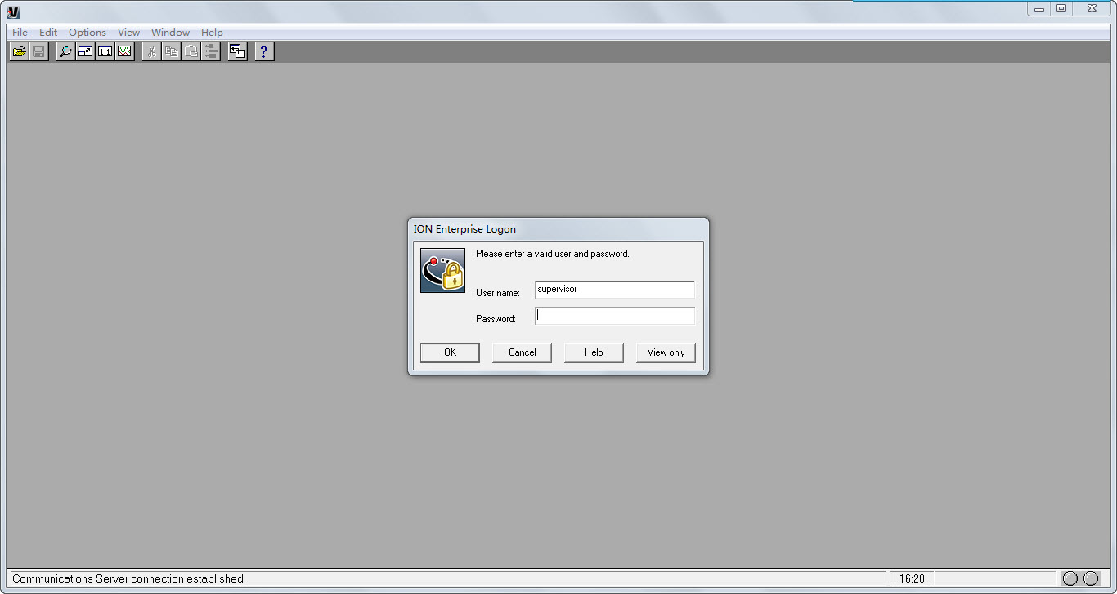

The default user interface appears.

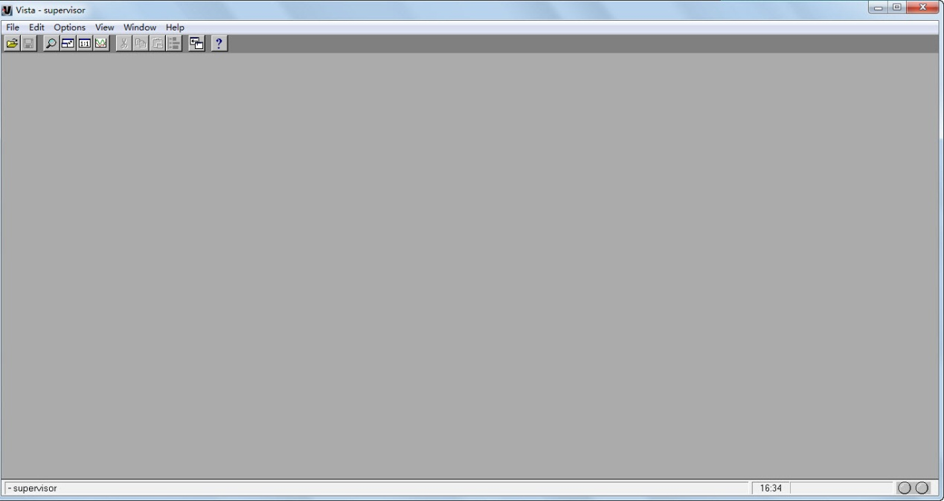

1. Select **Options** to ensure **Show Toolbox** is checked .

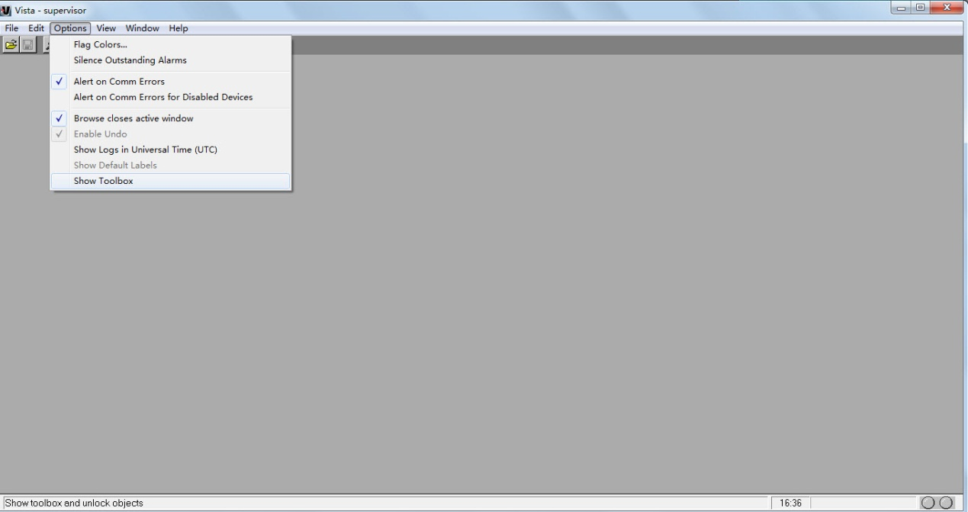

The **Diagram Objects** toolbox is shown on the lower right-hand corner as follows:

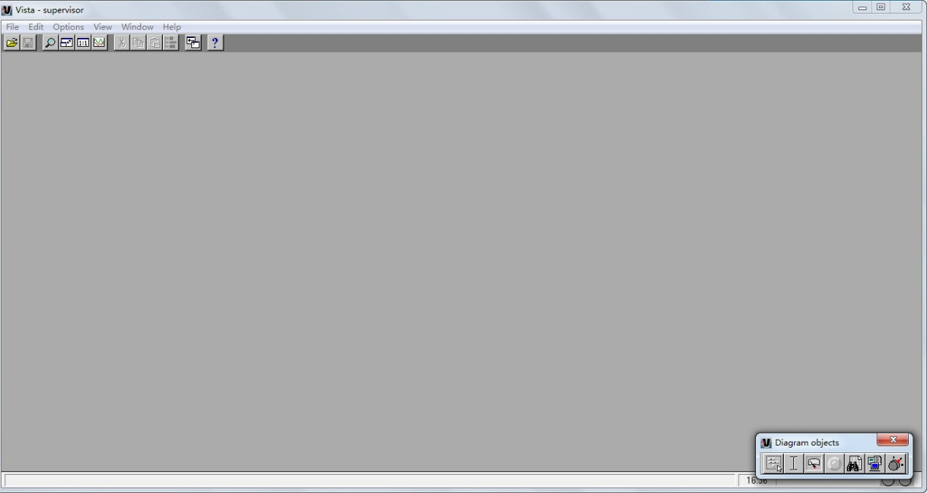

1. Select **File**🡪**Generate Network Diagram**.

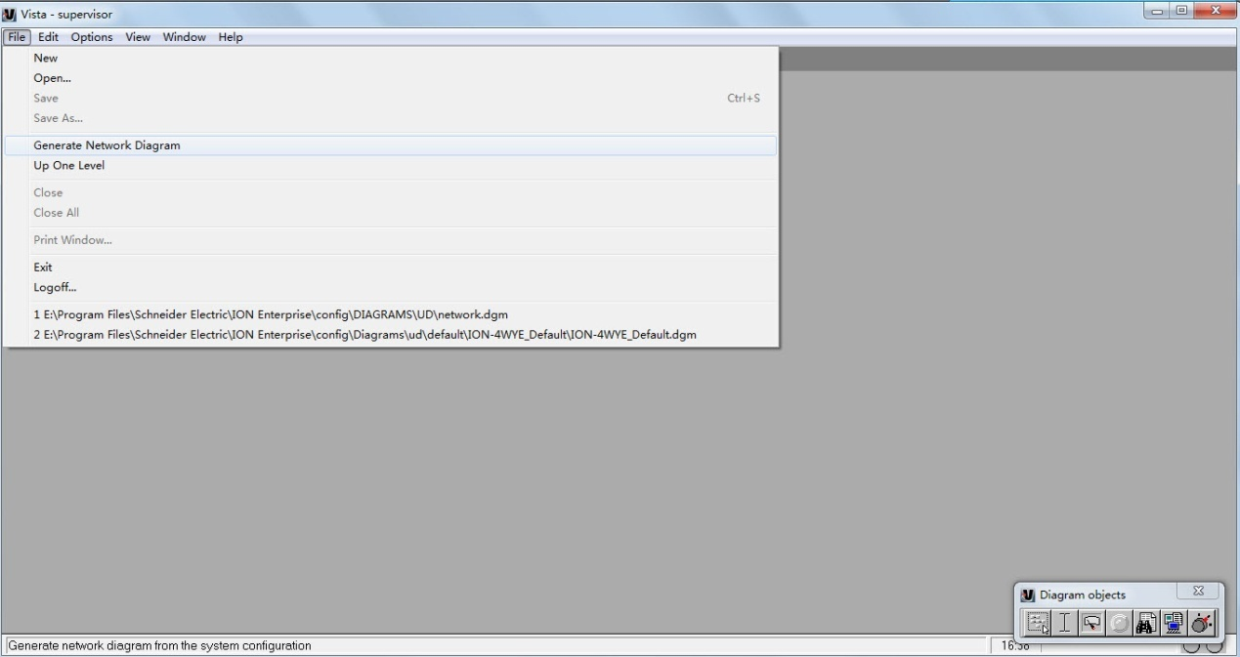

And then Vista automatically locates all sites and devices in the system and displays them.

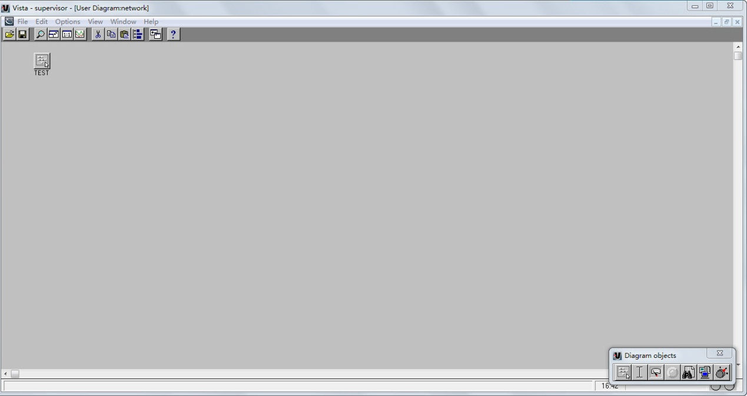

Double-click the site icon to view the devices inside the site.

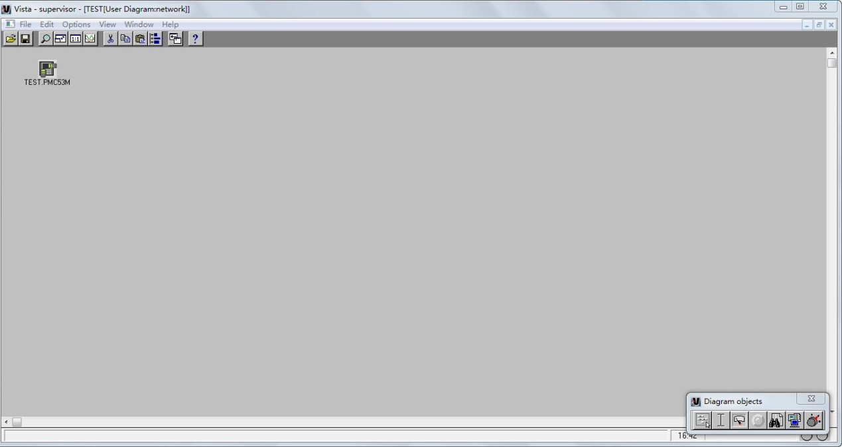

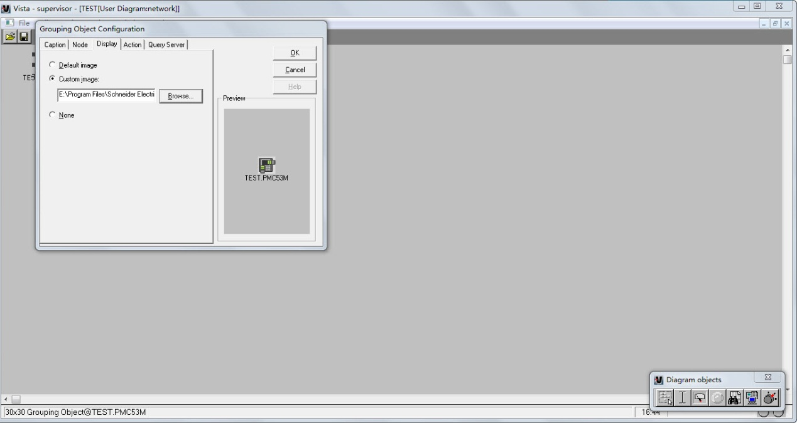

1. Draw a user diagram; you can use it to monitor the meter.

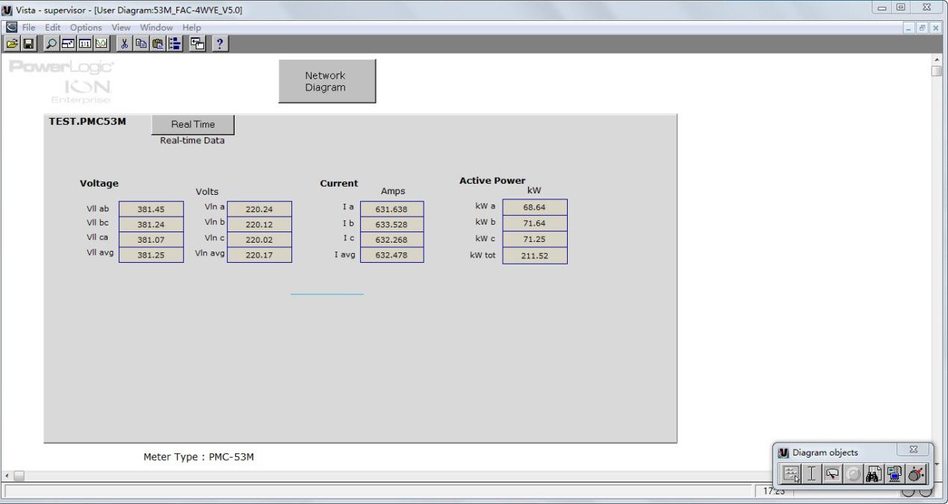

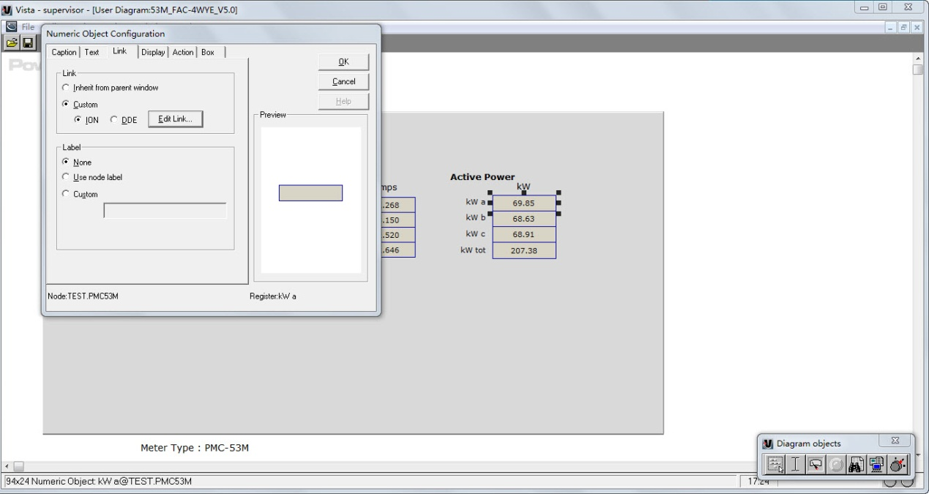

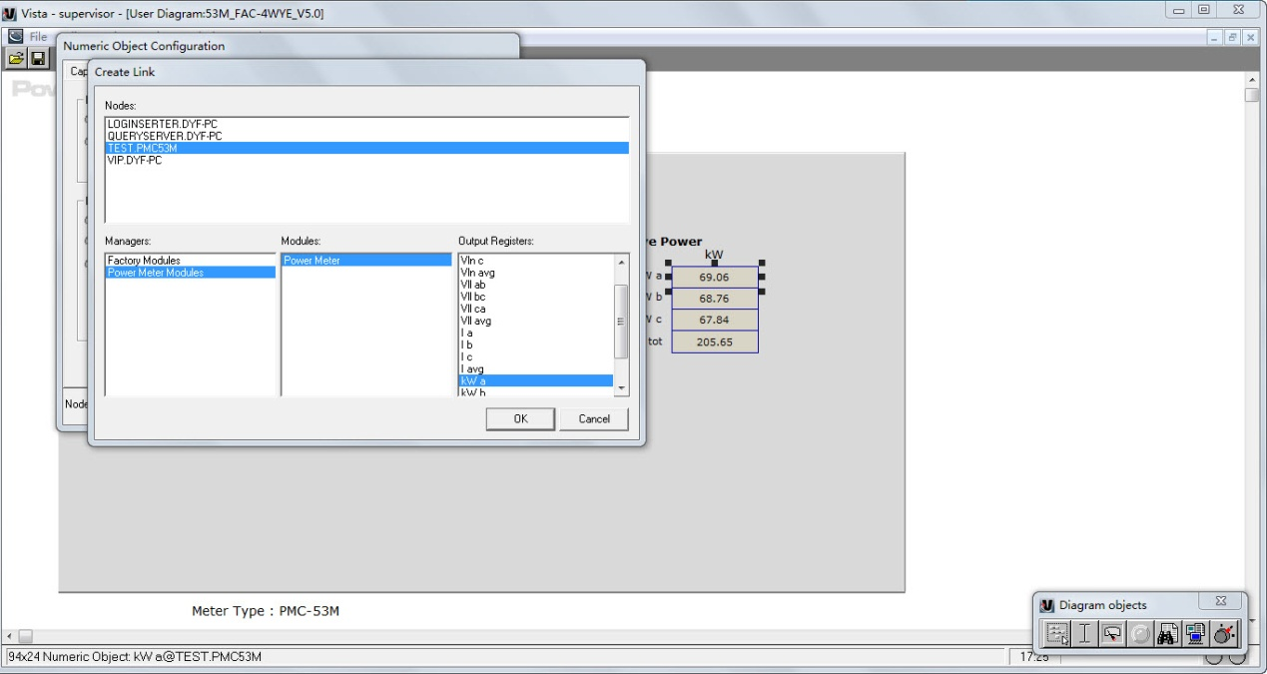

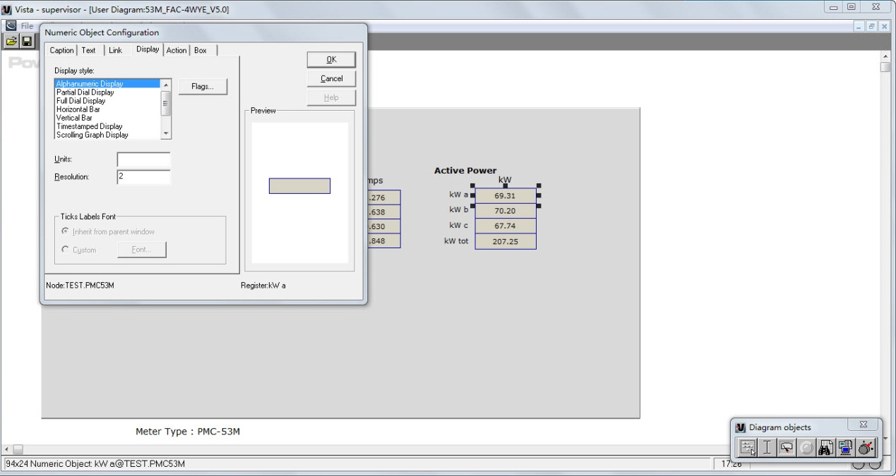

**EtherGate Connection of PMC meters through PMC-1380 in ION Enterprise**

PMC-1380 acts as a gateway that transfers data between an Ethernet network and the devices connected to it via RS-485.

1. Click the **Sites** icon. Right-click in the display window and select **New**🡪**Ethernet Gateway Site…**

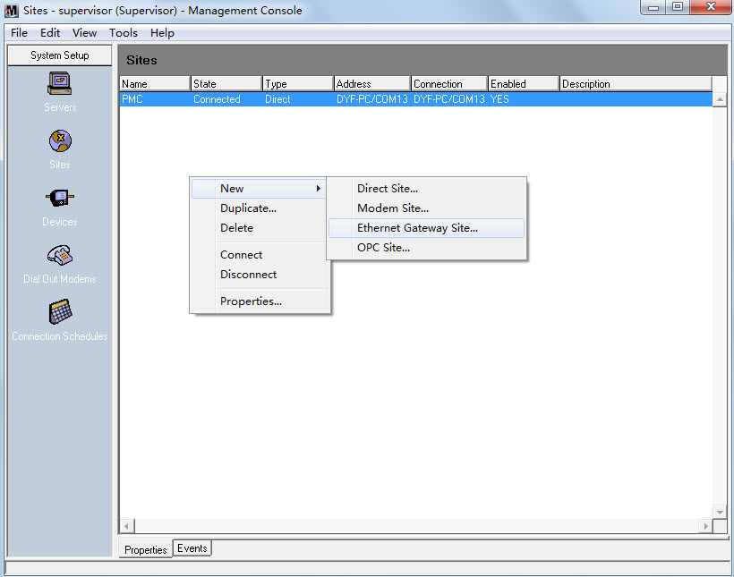

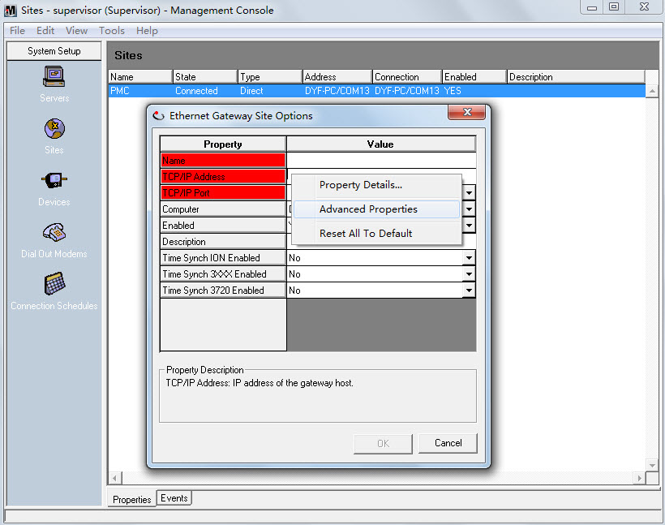

Fill in the **TCP/IP Address** and **TCP/IP Port** fields to match the settings of PMC-1380.

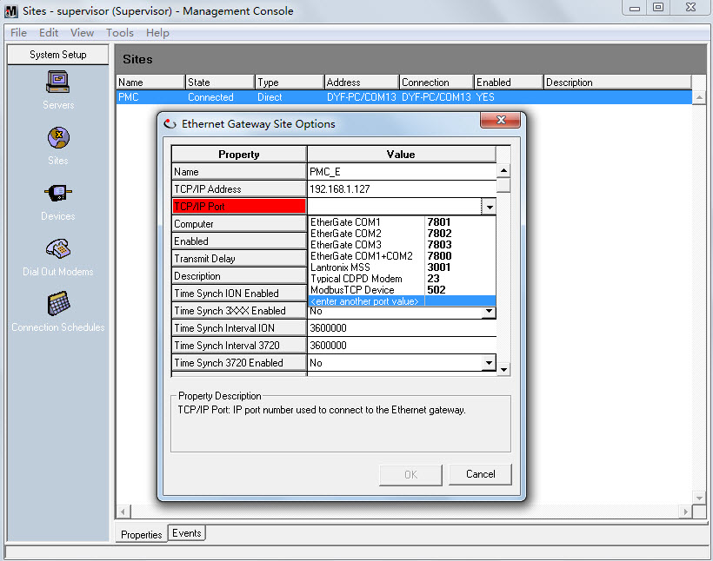

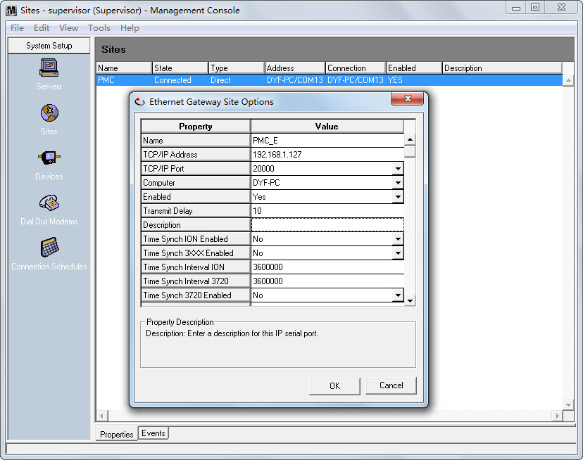

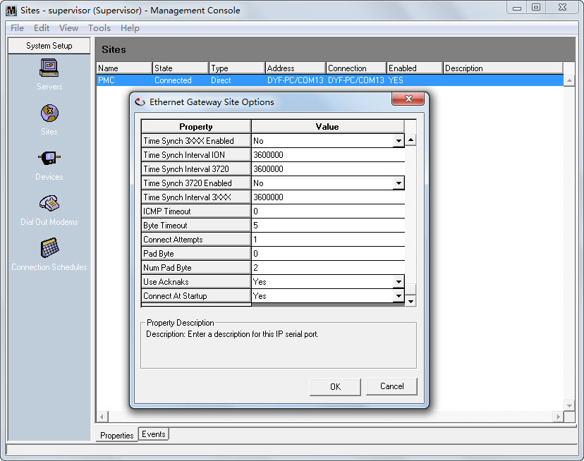

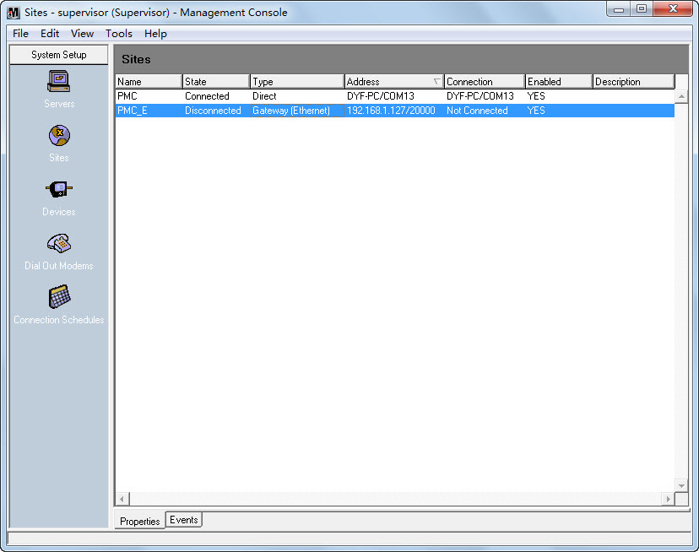

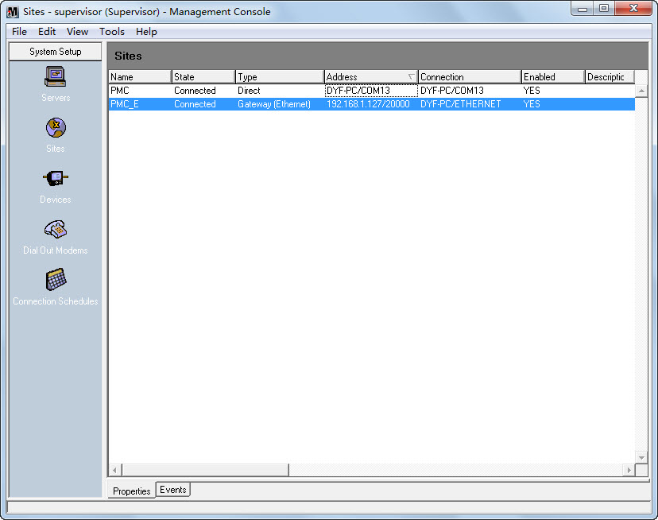

1. Click the **Devices** icon, Right-click in the display window and select **New**🡪**Serial Device on Ethernet Gateway Site…**.

